# 

### Semester One Examination, 2016

### Question/Answer Booklet

# MATHEMATICS

**SOLUTIONS**

**SPECIALIST**

**UNIT 1**

## Section One:

## Calculator-free

|  |  |  |  |  |  |  |  |  |
| --- | --- | --- | --- | --- | --- | --- | --- | --- |
| Student Number: In figures |  |  |  |  |  |  |  |  |

In words

Your name

## Time allowed for this section

Reading time before commencing work: five minutes

Working time for section: fifty minutes

## Materials required/recommended for this section

***To be provided by the supervisor***

This Question/Answer Booklet

Formula Sheet

***To be provided by the candidate***

Standard items: pens (blue/black preferred), pencils (including coloured), sharpener, correction fluid/tape, eraser, ruler, highlighters

Special items: nil

## Important note to candidates

No other items may be taken into the examination room. It is **your** responsibility to ensure that you do not have any unauthorised notes or other items of a non-personal nature in the examination room. If you have any unauthorised material with you, hand it to the supervisor **before** reading any further.

## Structure of this paper

|  |  |  |  |  |  |
| --- | --- | --- | --- | --- | --- |
| Section | Number of questions available | Number of questions to be answered | Working  time (minutes) | Marks available | Percentage of exam |
| Section One:  Calculator-free | 7 | 7 | 50 | 48 | 35 |
| Section Two:  Calculator-assumed | 13 | 13 | 100 | 101 | 65 |
|  | | | **Total** | 149 | 100 |

## Instructions to candidates

1. The rules for the conduct of examinations are detailed in the school handbook. Sitting this examination implies that you agree to abide by these rules.
2. Write your answers in this Question/Answer Booklet.
3. You must be careful to confine your response to the specific question asked and to follow any instructions that are specified to a particular question.
4. Spare pages are included at the end of this booklet. They can be used for planning your responses and/or as additional space if required to continue an answer.

* Planning: If you use the spare pages for planning, indicate this clearly at the top of the page.
* Continuing an answer: If you need to use the space to continue an answer, indicate in the original answer space where the answer is continued, i.e. give the page number. Fill in the number of the question that you are continuing to answer at the top of the page.

1. **Show all your working clearly**. Your working should be in sufficient detail to allow your answers to be checked readily and for marks to be awarded for reasoning. Incorrect answers given without supporting reasoning cannot be allocated any marks. For any question or part question worth more than two marks, valid working or justification is required to receive full marks. If you repeat any question, ensure that you cancel the answer you do not wish to have marked.
2. It is recommended that you **do not use pencil**, except in diagrams.
3. The Formula Sheet is **not** to be handed in with your Question/Answer Booklet.

Section One: Calculator-free 35% (50 Marks)

This section has**seven (****7)** questions. Answer **all** questions. Write your answers in the spaces provided.

Working time for this section is 50 minutes.

Question 1 (7 marks)

(a) Evaluate

(i) . (2 marks)

|  |
| --- |
| **Solution** |
|  |
| **Specific behaviours** |
| ✓ expands and cancels  ✓ simplifies |

(ii)  . (3 marks)

|  |
| --- |
| **Solution** |
|  |
| **Specific behaviours** |
| ✓ uses P and C notation correctly  ✓ cancels like factorials  ✓ simplifies answer |

(b) Determine the values of a and b given  (2 marks)

|  |
| --- |
| **Solution** |
|  |
| **Specific behaviours** |
| ✓ factors out 8! to obtain a  ✓ simplifies rest of expression to obtain b |

Question 2 (6 marks)

Given  and , determine

(a) . (1 mark)

|  |
| --- |
| **Solution** |
|  |
| **Specific behaviours** |
| ✓ determines vector |

(b) . (1 mark)

|  |
| --- |
| **Solution** |
|  |
| **Specific behaviours** |
| ✓ determines vector |

(c) . (2 marks)

|  |
| --- |
| **Solution** |
|  |
| **Specific behaviours** |
| ✓ determines vector  ✓ determine magnitude |

(d) a unit vector in the same direction as . (2 marks)

|  |
| --- |
| **Solution** |
|  |
| **Specific behaviours** |
| ✓ determines magnitude of vector  ✓ determines unit vector |

Question 3 (7 marks)

(a) Prove that the opposite angles of a cyclic quadrilateral are supplementary. (4 marks)

|  |
| --- |
| **Solution** |
| $∠DOB=2α$ (angle on arc $DCB$ at centre is twice angle on circumference) $∠DOB=2β$ (angle on arc $DAB$ at centre is twice angle on circumference) $2α+2β=360$ (angle sum of circle) $α+β=180$ - opposite angles are supplementary |
| **Specific behaviours** |
| ✓ labelled diagram  ✓ uses angle at centre twice circumference  ✓ uses angle sum at centre  ✓ completes proof |

(b) Determine, with reasons, the size of  in the diagram below. (3 marks)

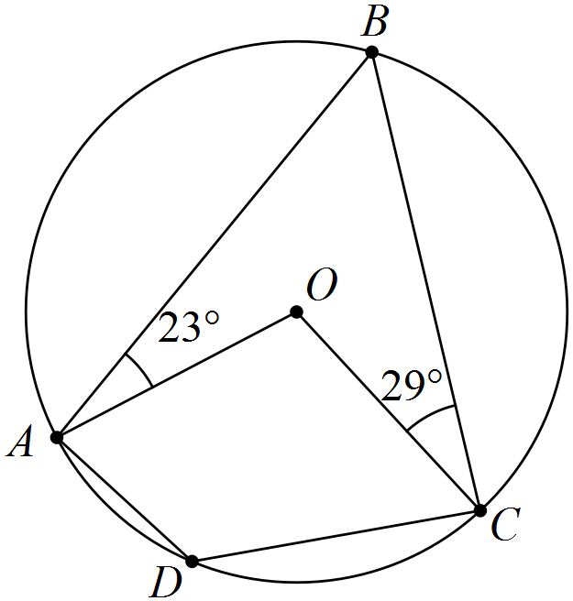

|  |
| --- |
| **Solution** |
|  |
| **Specific behaviours** |
| ✓ uses isosceles triangles  ✓ determines  ✓ determines  with reason |

Question 4 (7 marks)

Consider the vectors ,  and .

(a) Determine the magnitude of . (3 marks)

|  |
| --- |
| **Solution** |
|  |
| **Specific behaviours** |
| ✓ determines resultant  ✓ uses magnitude formula  ✓ states correct magnitude |

(b) Express c in the form . (4 marks)

|  |
| --- |
| **Solution** |
|  |
| **Specific behaviours** |
| ✓ writes simultaneous equations  ✓ eliminates one variable and solves  ✓ solves for other variable  ✓ writes in required form |

Question 5 (8 marks)

(a) An equilateral triangle of side 2a circumscribes a circle, as shown in the diagram below. Express the exact radius of the circle in terms of a. (4 marks)

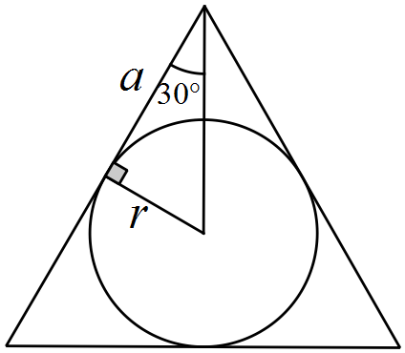

|  |
| --- |
| **Solution** |
|  |
| **Specific behaviours** |
| ✓ draws right triangle using tangent and radius  ✓ places angle and variables on diagram  ✓ determines relationship between r and a  ✓ expresses r in terms of a |

(b) Two circles touch internally at B, as shown below. AB, AC and AD are tangents,  and . Determine, with reasons, the size of . (4 marks)

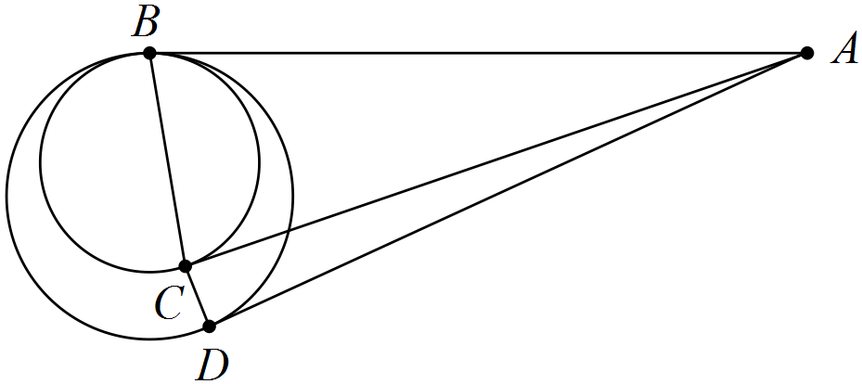

|  |
| --- |
| **Solution** |
| As B is common to both circles, then as tangents from external point,  and  . Hence triangles ABC and ACD are both isosceles. |
| **Specific behaviours** |
| ✓ explains why  ✓ determines  ✓ determines  ✓ determines |

Question 6 (7 marks)

(a) In the diagram below,  and .

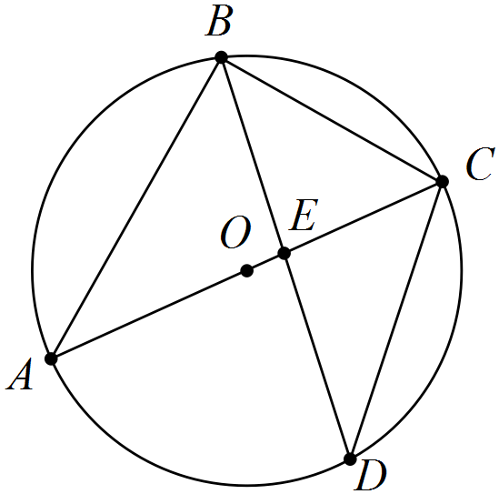

Determine the size of the following angles.

(i) . (1 mark)

|  |
| --- |
| **Solution** |
|  |
| **Specific behaviours** |
| ✓ states angle |

(ii) . (1 mark)

|  |
| --- |
| **Solution** |
|  |
| **Specific behaviours** |
| ✓ states angle |

(iii) . (1 mark)

|  |
| --- |
| **Solution** |
|  |
| **Specific behaviours** |
| ✓ states angle |

(b) In the diagram below, AB and AC are tangents to the circle and . Determine, with reasons, the sizes of  and . (4 marks)

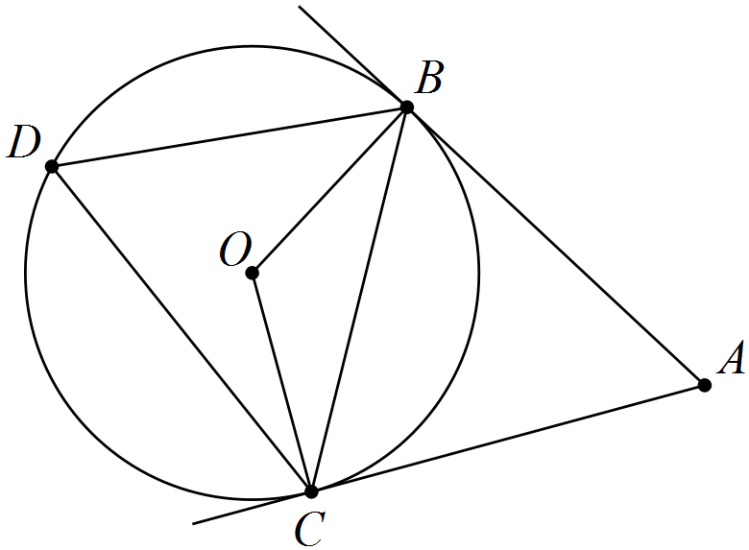

|  |
| --- |
| **Solution** |
|  |
| **Specific behaviours** |
| ✓✓ angle BDC with reason  ✓✓ angle BOC with reason |

Question 7 (6 marks)

(a) Show that  when  but not when . (2 marks)

|  |
| --- |
| **Solution** |
|  |
| **Specific behaviours** |
| ✓ clearly demonstrates first case is true  ✓ demonstrates second case is false |

(b) Prove by contradiction that, for every positive real number x, . (5 marks)

|  |
| --- |
| **Solution** |
| Assume there exists a positive real number x such that .  Since , then  and , and so inequality can be multiplied by  without reversing inequality direction.  Hence    This results in the contradiction that  and so we must conclude that no such positive real number x exists so that , hence proving that. |
| **Specific behaviours** |
| ✓ writes contra of proof  ✓ cross multiplies  ✓ notes no need to reverse inequality  ✓ simplifies inequality  ✓ makes conclusion |

Additional working space

Question number: _________

Additional working space

Question number: _________

© 2016 WA Exam Papers. Rossmoyne Senior High School has a non-exclusive licence to copy and communicate this paper for non-commercial, educational use within the school. No other copying, communication or use is permitted without the express written permission of WA Exam Papers.